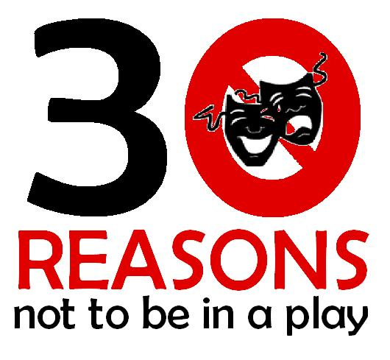
Rehearsal Schedule
Due to the nature of this show, all actors are called to all rehearsals.

DATE | DAY | TIME | NOTES
9/29 | Monday | 3:45-6:30 PM | Continue Improvisation Work
9/30 | Tuesday | 3:45-6:00 PM | Complete improvisation work. Begin formalizing blocking.
10/1 | Wednesday | 3:45-5:45 PM | Continue formal blocking.
10/6 | Monday | 3:45-6:30 PM | Continue formal blocking.
10/7 | Tuesday | 5:30-8:00 PM | Complete formal blocking.
10/8 | Wednesday | 3:45-5:45 PM | Work and run first half.
10/9 | Thursday | 5:30-8:00 PM | Work and run second half.
10/14 | Tuesday | 5:30-8:00 PM
10/15 | Wednesday | 3:45-5:45 PM | First half goes OFF-BOOK!
10/16 | Thursday | 3:45-6:00 PM | Second half goes OFF-BOOK!
10/20 | Monday | 6:00-8:00 PM | FULL SHOW – OFF-BOOK!
10/21 | Tuesday | 3:45-6:00 PM | Working run – add props.
10/22 | Wednesday | 3:45-5:45 PM | Run – add sound and lighting.
10/23 | Thursday | 5:30-8:00 PM | Run – add sound and lighting.
10/27 | Monday |  | Costume parade. Dress rehearsal.  [We need to set time. When do Juniors have to work on preparing for Fall Festival?]
10/28 | Tuesday |  | Fall Festival.  [We need to set times here too.]
10/29 | Wednesday | 4:00-7:00 PM | Final Dress Rehearsal.
10/30 | Thursday | 6:00 Call  7:00 Curtain | Public Performance.  (This will probably be chapel performance day too.)
10/31 | Friday | 3:45-5:45 PM | Clean and prep final version.
11/1 | Saturday | 12:00 PM | Emergency Rehearsal – if needed
11/3 | Monday | 3:45-6:30 PM | Final rehearsal. Possible load-in and rehearsal at Stratford.
11/4 | Tuesday | 8:00 AM | Leave school for competition at Stratford.

