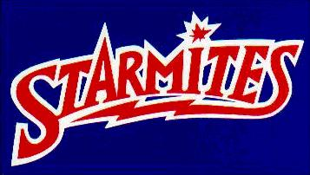
Costume Price List

You may purchase your own costume only at this time. I’ll open everything up to any buyer after Spring Break. You do not have to buy your costume. This list is only in response to the interest many of you had in purchasing costume pieces.

Checks should be made out to FPD. Checks are preferred, but cash is accepted.

BANSHEES
Black Camo Shirt | $5.00
Leggings | NOT FOR SALE
Tutu | $15.00
Lace Gloves | $5.00
Neon Gloves | $3.00
Leg Warmers | $6.00
Studded Bracelet | $1.00
Studded Choker | $1.00

STARMITES
Tie-Dye Shirt | $5.00
Camo Pants | $15.00
Boots | $15.00
Bandana | $1.00
Belt | $2.00
Studded Gloves | $3.00
Hat | $3.00
Punk’s Gray Shirt | NOT FOR SALE

DROIDS
Flight Suit | NOT FOR SALE
Faceless Mask | $8.00
Pinboard | $5.00
Neon Gloves | $3.00

SHAK GRAA/TRINKULUS
Nothing is for sale except:
Iquana Mask & Make-Up | $15.00
Shredded Camo Shirt/Pants | $5.00

Continued on back →

ELEANOR/DIVA/BIZARBARA
Pink Camo Shirt | $5.00
“Biker Chick” Outfits | NOT FOR SALE
Arm Warmers | $5.00
Green Tights | $3.00
Lace Gloves | $5.00
Supergirl Shirt | $15.00
Plaid Skirts | FREE! (ha ha)
Pink Boa | $5.00
Camo Hat | $3.00
White Tutu | $15.00

