PLEASE READ THESE NOTES
OR RISK UTTER CONFUSION!

Okay, here’s the plan. I have decided to try something completely crazy this year. I did not want to cut 20 people from the cast – especially considering the strong work I saw at the auditions. The answer: a complete double cast – and no understudies.

How does it work? Both casts are COMPLETELY EQUAL. I have gotten permission to add a performance – a Saturday matinee. One cast (still to be decided) will perform on Thursday night and the Saturday Matinee. The other cast will get Friday and Saturday night. This evenly splits our traditionally two strongest nights (Thursday and Saturday) among the casts. What about the names of the casts? Just me being silly – those are the two places most associated with Shakespeare. They are also the two places that the Royal Shakespeare Company regularly performs today.

How will it work in rehearsals? We will block the play together. One cast will walk the blocking while the other cast writes it down in the audience. Then we switch. For the next scene we’ll do it the other way around…and so on. The last week before the show I’m looking to have two full rehearsals on the Saturday, Monday, Tuesday, and Wednesday. You would only come to the rehearsal for your cast – unless you wanted to be supportive of your twins and come watch the other one! I’m still figuring all of the details out about the schedule. I am convinced that it can work.

I expect you to be incredibly supportive of your cast twin. You will be working together a great deal on lines and blocking. You are also each other’s understudy.

This should be a truly original rehearsal process for us. Thank you for coming along on the journey.

First rehearsal: Tuesday, March 24, 3:45-6:30 PM in the auditorium. Please bring a pencil.

Second rehearsal: Wednesday, March 25, 3:45-5:45 PM.

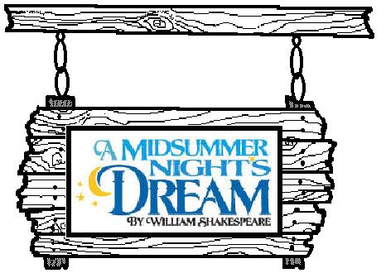

Cast List – in order of appearance

 | London Cast | Stratford-upon-Avon Cast
THE COURT
Theseus | Connor Tolbert | Robert Peavy
Hippolyta | Kristen Hobbs | Anna Gainey
Philostrate | Macy Ellis | Anna Daly Bullard
Egeus (and Oberon’s train) | Logan McDonald | Adam Gorman
THE LOVERS
Lysander | Jeremy Bullard | Michael Money
Demetrius | Matt Doremus | Samuel Douglas
Hermia | Kristen Oetter | Jessica Fleming
Helena | Mackenzie Scott | Anne Strickland
THE MECHANICALS
Bottom/Pyramus | Zach Shealy | Michael Bragg
Quince/Prologue | Lane Letson | Meredith Pierce
Flute/Thisby | Stephen Dennis | Mikey Eller
Starveling/Moonshine | Victoria Vanhuss | Dana Sams
Snout/Wall | Alyssa Kuncaitis | Kathryn Lengel
Snug/Lion | Kathryn Kostovetsky | Hunter Layton
THE FAIRIES
Puck | Adriana Figueroa | Katie Huggins
Oberon | Alex Newberry | Chad Gainey
Titania | Olivia Newsome | Colby Watson
Fairy/Peaseblossom | Madison Kross | Lily Garnett
Mustardseed | Claire Carter | Olivia Taylor
Cobweb | Madison Howard | Elizabeth Tate
Moth | Maisy McDonald | Cecilia Bullard

